W/C 16th January
Post 1
We are very excited because 2023 sees the first year of the IAPD Fellowship!

“Your IAPD Fellowship Certificate will reassure parents of your contemporary knowledge and expertise.” Jorge Castillo President IAPD

FIND OUT MORE WITH OUR LIVE Webinar: IAPD Fellowship Information Session

Please join us for a live session hosted by Prof. Marcelo Bonecker, IAPD Immediate Past President, Chair of the Fellowship Committee. He will be sharing his thoughts on the Fellowship and answering your questions.

Sunday 22nd January, 14:00 UTC
Register at https://us02web.zoom.us/webinar/register/WN_sq1cv8KaS_-Ok6K2kUAvuw

#iapdfellowship

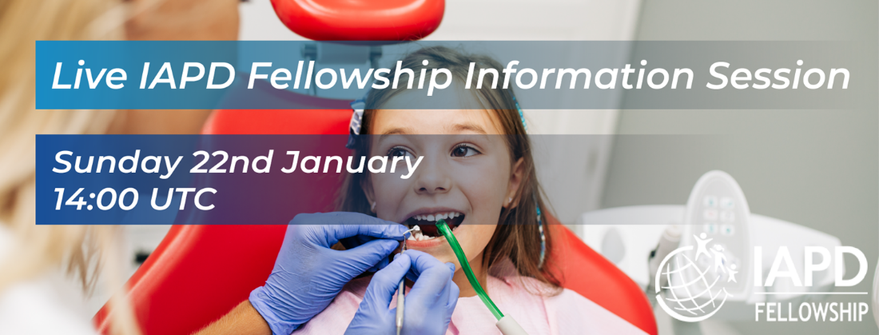
Image file name: 16Janpost1

Post 2
Don’t forget to register for the LIVE Webinar: IAPD Fellowship Information Session
“Putting FIAPD after your name will reinforce your personal reputation both for high standards of professional excellence, and your commitment to continuous learning.”
Jorge Castillo, President IAPD

Please join Prof. Marcelo Bonecker, IAPD Immediate Past President, Chair of the Fellowship Committee. He will be sharing his thoughts on the Fellowship and answering your questions.

Sunday 22nd January, 14:00 UTC
Register at https://us02web.zoom.us/webinar/register/WN_sq1cv8KaS_-Ok6K2kUAvuw
#iapdfellowship

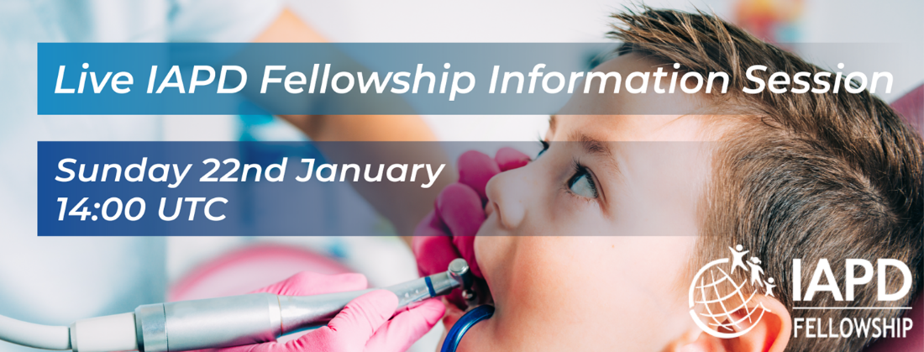
Image file name: 16Janpost2

W/C 23rd January
Thank you to everyone who participated in our IAPD Fellowship Information Session live webinar. The recorded webinar can be found at www.xxxxx

Don’t forget the deadline for IAPD Fellowship exam application is 31st March 2023.

If you have further questions please email exam@iapdfellowship.com

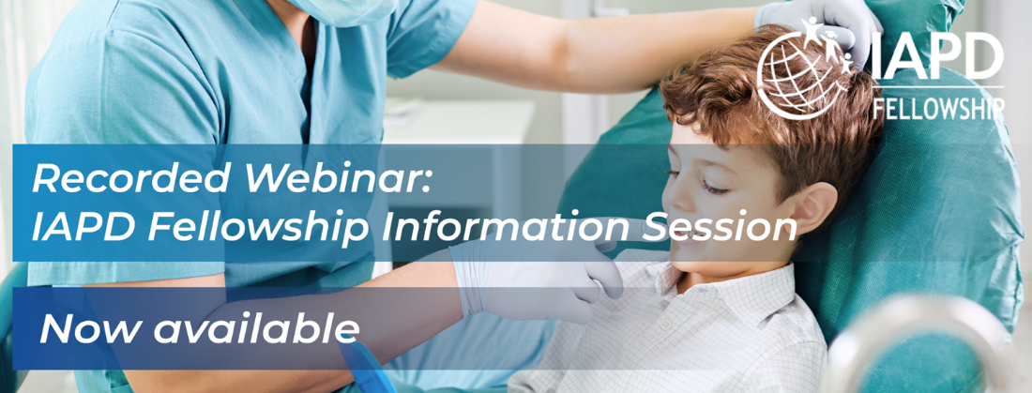
Image file name: 23Jan

W/C 30th January
Do you want the post nominal letters FIAPD after your name?

Show the world your in-depth knowledge of paediatric dentistry and your commitment to continuous professional development by being a Fellow of the International Association of Paediatic Dentistry.

Find out more www.iapdworld.org/fellowship

Applications close 31st March 2023.

#iapdfellowship

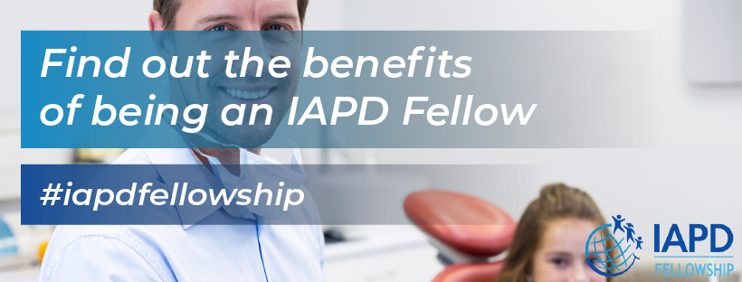
Image file name: 30Jan

W/C 6th February

Is there room on your practice wall for a new certificate?

“Your IAPD Fellowship Certificate will reassure parents of your contemporary knowledge and expertise.”
Jorge Castillo, President IAPD

Apply for the IAPD Fellowship Exam now at www.iapdworld.org/fellowship

Applications close 31st March 2023.

#iapdfellowship

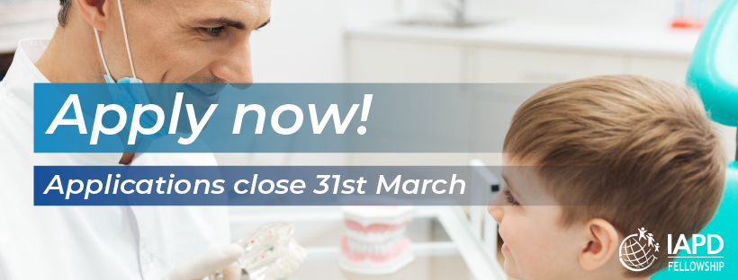

Image file name: 6Feb

W/C 13th February

Looking to secure new patients?

An IAPD Fellowship Certificate will reassure parents of your advanced skills and expertise.

Apply now for the IAPD Fellowship Exam:

www.iapdworld.org/fellowship

#iapdfellowship

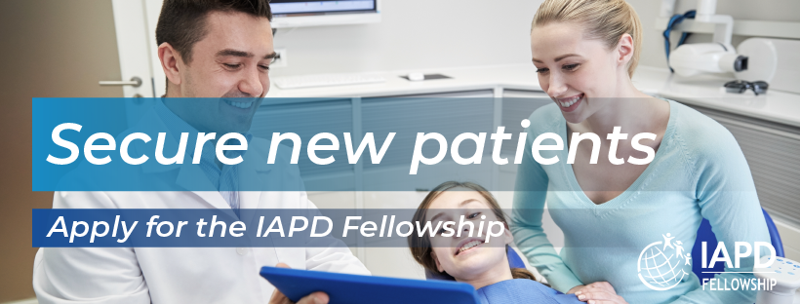

Image file name: 13Feb

W/C 20th February

Career advancement and independent recognition of high standards are just two benefits to enjoy as an IAPD Fellow

Find out more www.iapdworld.org/fellowship

Applications close 31st March 2023.

#iapdfellowship

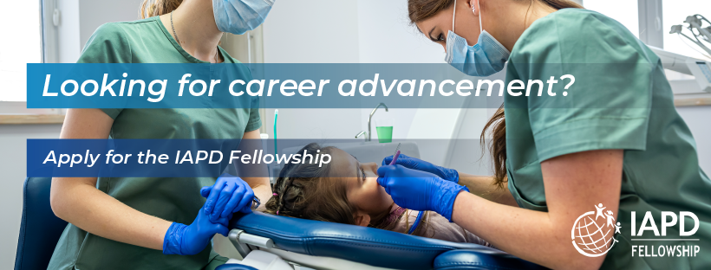
Image file name: 20Feb

W/C 27th February
Be one of the first IAPD Fellows and enjoy the benefit of attracting and retaining patients.

Apply for the IAPD Fellowship exam now:
www.iapdworld.org/fellowship

#iapdfellowship

Image file name: 27Feb

W/C 6th March
Time is running out to put FIAPD letters after your name.
“Putting FIAPD after your name will reinforce your personal reputation both for high standards of professional excellence, and your commitment to continuous learning. Your IAPD Fellowship Certificate will also reassure parents of your contemporary knowledge and expertise.”
Jorge Castillo
President IAPD

Applications for the IAPD Fellowship examination close on 31st March.
Apply for the IAPD Fellowship exam now:
www.iapdworld.org/fellowship

#iapdfellowship

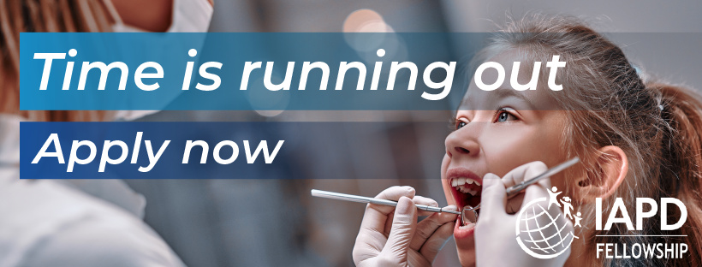
Image file name: 6March

W/C 13th March
Be a pioneer in your profession as one of the first IAPD Fellows, demonstrating to your colleagues your commitment to continuing professional development.

Apply to be an IAPD Fellow now!
www.iapdworld.org/fellowship

#iapdfellowship

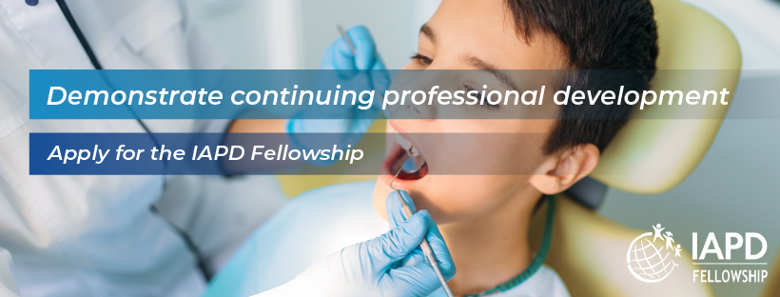

Image file name: 13March

W/C 20th March
The Count Down is On!

Only 2 weeks left to apply for the IAPD Fellowship exam to reinforce your personal reputation both for high standards of professional excellence, and your commitment to continuous learning.

Apply now:
www.iapdworld.org/fellowship

#iapdfellowship

Image file name: 20March

W/C 27th March
Last chance to apply to use the postnominal letters FIAPD after your name
This is your last chance to apply to be a Fellow of the International Association of Paediatic Dentistry, and therefore be able to put the postnominal letters FIAPD after your name. Completing the fellowship will demonstrate your contemporary knowledge of paediatric dentistry and your commitment to continuous professional development.

Apply now:
www.iapdworld.org/fellowship

#iapdfellowship

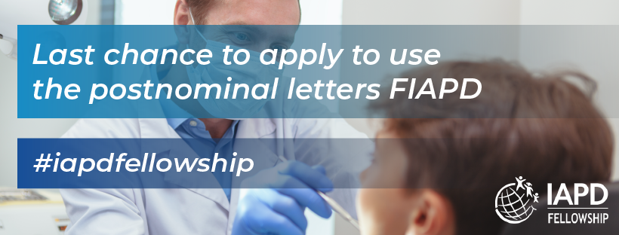

Image file name: 27March

