Post 1:
Shape the future of children’s oral health in Barcelona!
Join the IAPD 4th Global Summit, 13–15 November 2026, for evidence-based discussions on early orthodontics and paediatric dentistry.
Submit your abstract by 15 July 2026
Register early by 25 August 2026
www.iapdsummit.org
#IAPD2026 #EarlyOrthodontics #PaediatricDentistry
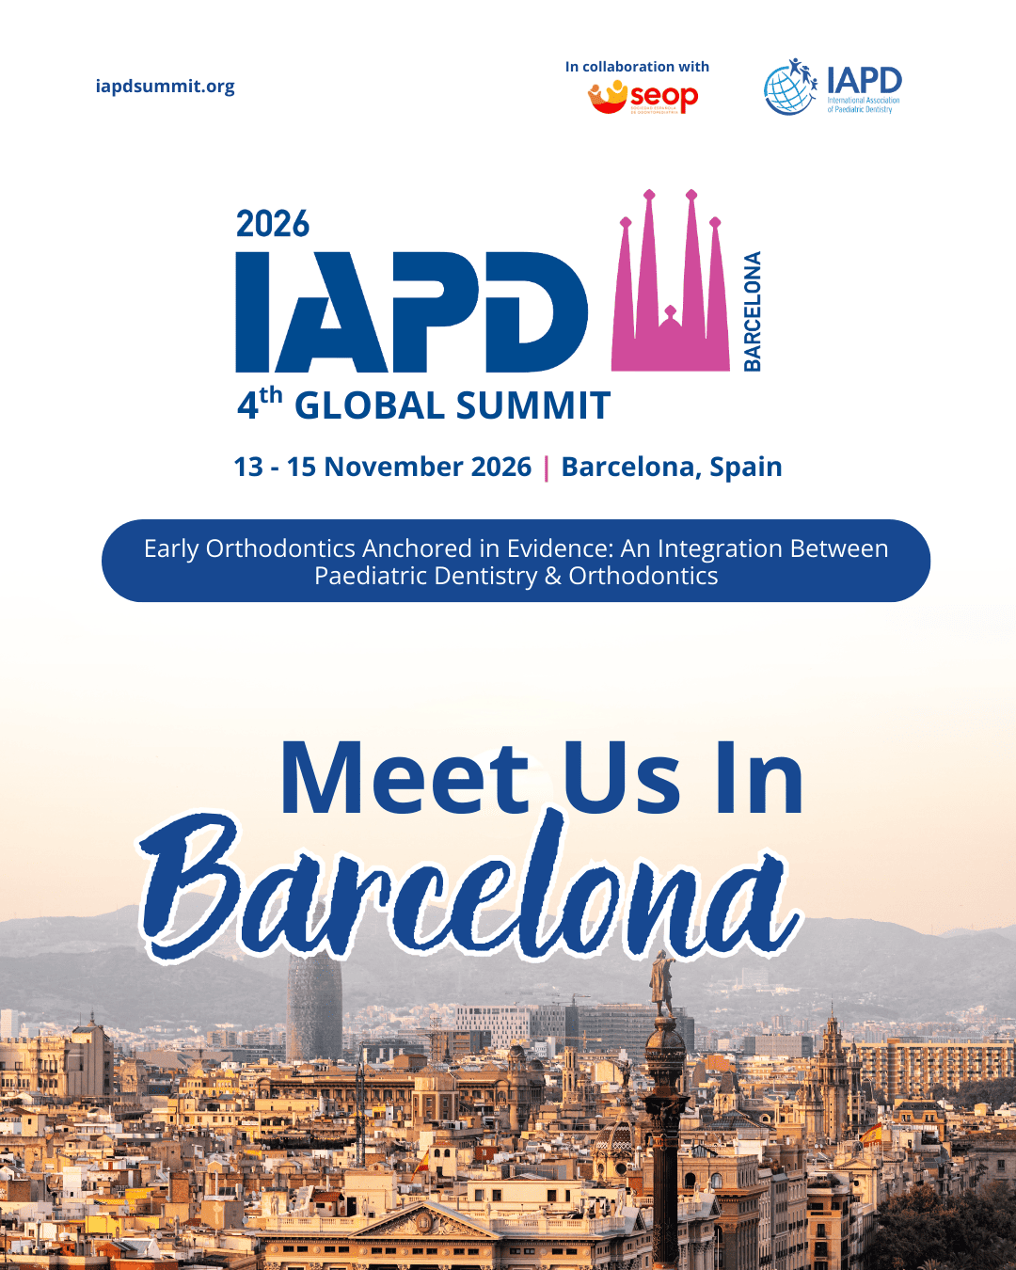

Post2:
Barcelona is calling!
Be part of the IAPD 4th Global Summit and join global experts in exploring the latest evidence in early orthodontics and paediatric dentistry.
Abstract deadline: 15 July 2026
Early-bird deadline: 25 August 2026
www.iapdsummit.org


Post3:
Your voice belongs in Barcelona.
Share your research, learn from global experts, and connect with colleagues working to improve oral health for children worldwide.
IAPD 4th Global Summit
13–15 November 2026 | Barcelona, Spain
Abstracts close: 15 July 2026
Early-bird ends: 25 August 2026
www.iapdsummit.org
